LED Cross software operation manual
(based on C-Power)

A． run and set up the software 2
1.run the software 2
1.1.1 Setup signs(define LED screen) 2
B．C-Power parameters setting 11
1.enter the interface of led-tool parameters setting 11
2.Led cross wiring 12
C．edit and manage program 12
1.learn about the interface of software 12
2.create and edit programs 13

A．run and set up the software

1.Run the software
Run “Start” - “All programs” - “Led Cross V1.0” - “Led Cross V1.0”; or double-click “Led Cross ” shortcut icon on the desktop directly.
The interface of LedCross only supports English for now.
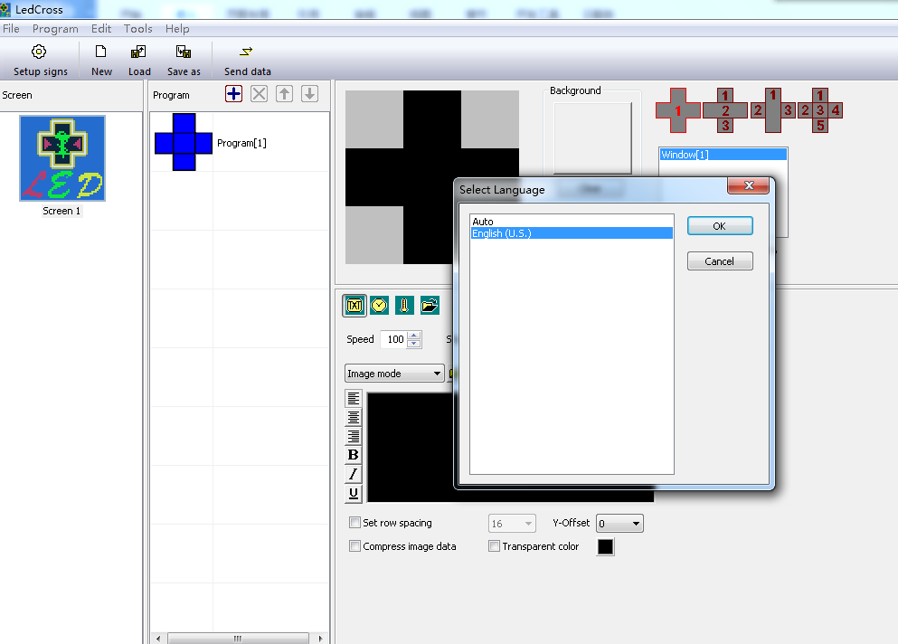
figure 1

“Setup signs”（define LED screen）
（searching controllers; setting screen parameters）
The soft ware setting is to perform “Define LED screen”.
Purpose: when the software is run for the first time, the LED screen definition is the first step, which aims to establish the program and set the communication mode. After that, the LedCross software is combined with the LED screen hardware through the program.
Methods and steps:
- Click“setup signs”or“File” --“setup signs”enter“LED Screen”（define LED screen），as shown in figure 2.
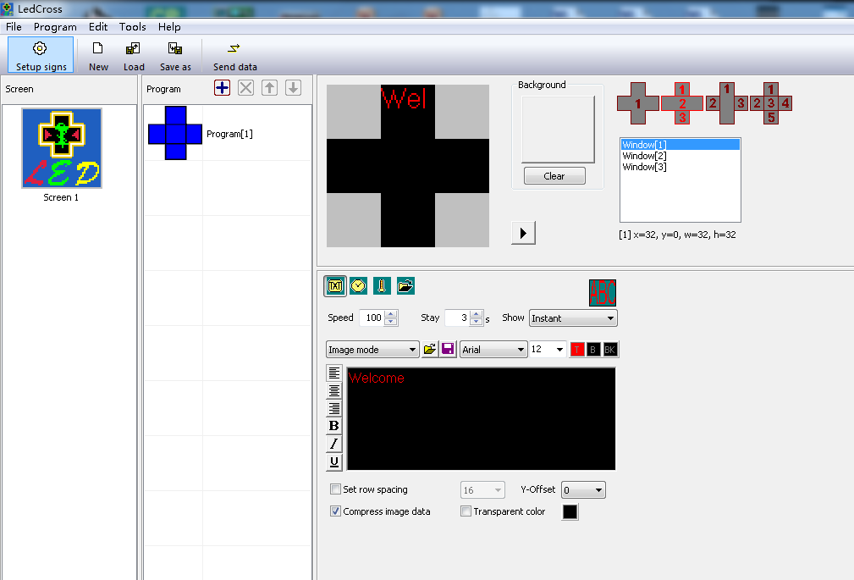
figure 2
Click this to define LED screen
- In the LED screen list dialog box (Error: Reference source not found), click “New” button to establish a new screen or click “Edit” to change the screen parameters.Or you can also delete the screen you have defined by clicking “delete”.
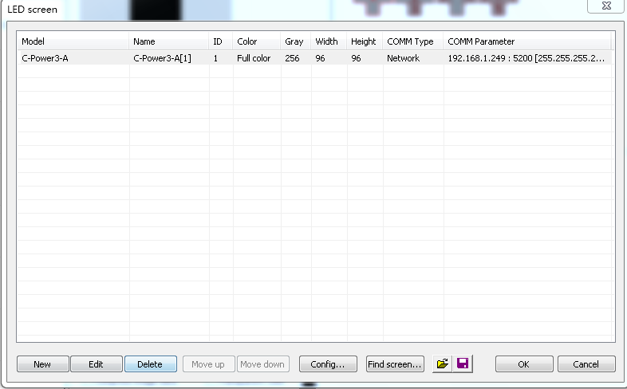
图 3
- If the controller has connected into the computer(COM port or network port), click “Find screen” button(or click “Tools”-“Find device” on the menu), the “search device” dialog box pops up, so we can search the devices which have connected into the computer.as shown as figure 4,figure 5,figure 6.
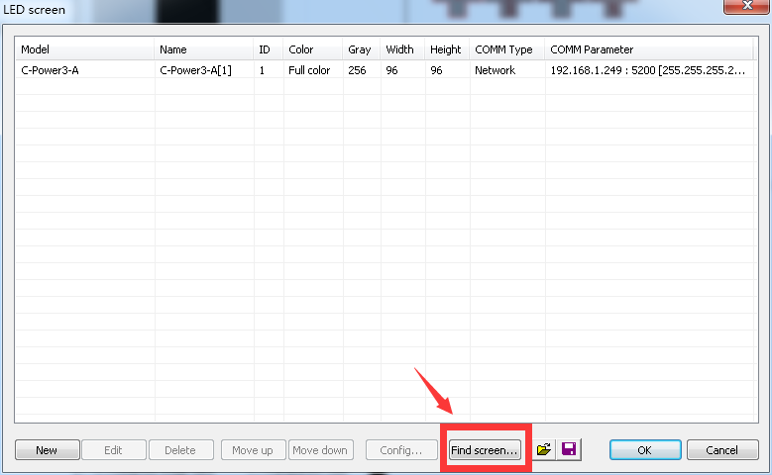
Figure 4

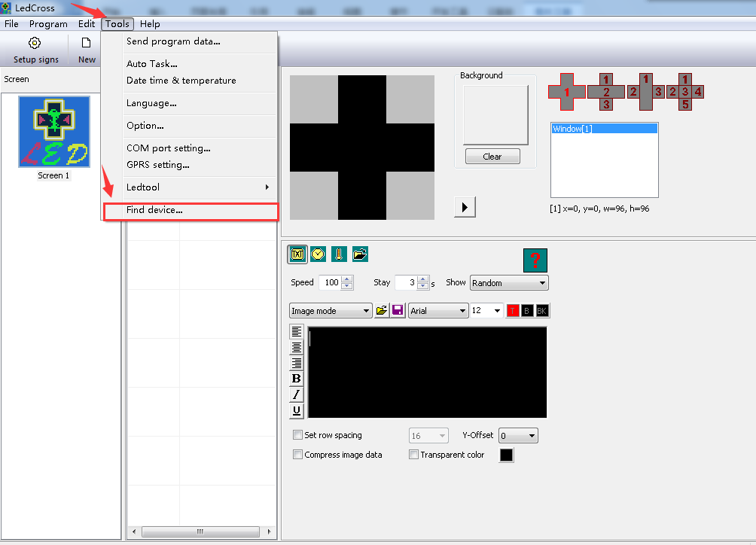
Figure 5
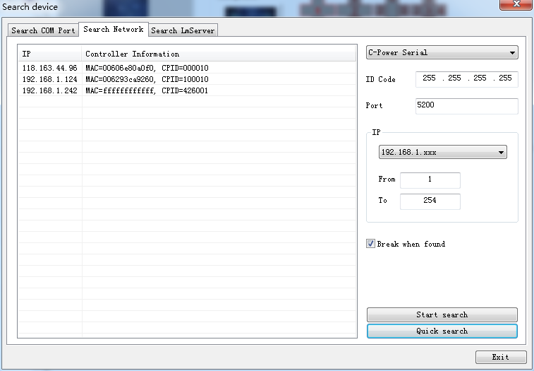
If the controllers are connected to the computer by network，click“Quick search ”can find the controllers quickly.
Choose the search mode according to the way controller connects to the computer
These two parameters just keep them defaulted,you don’t need to change them.
Figure 6

- After clicking “New” or “Edit” button, enter the password in the authority confirmation box, and the box of “Screen editor” pops up, as shown in Error: Reference source not found and Error: Reference source not found8.
- In the dialog box of “Screen editor”, define LED screen according to the hardware setting condition of the screen controller.
          - Model: select the correct controller type at the left side of the dialog box.
          - Name: user can name the LED screen freely. The name will appear at the edit field. If no name input, the system will automatically display the type of controller (ID).
          - ID: it is used to distinguish two or more LED screens. If there is only one screen, use the default value “1”.
          - Color: select the color of the LED screen: Full color.
          - Width and Height: actual pixels of the LED screen.for now Ledcross supports 48x48,72x72,96x96 size.
          - Font library: click button can set the font library type, if the controller has connected well, the font libraries which have installed on the controller can be auto detected.
          - Communication type: select COM port mode, network mode, or GPRS/CDMA mode.
- COM port mode: RS232 or RS485 mode
It needs to set the original port of PC COM port communication, and then Baud rate.

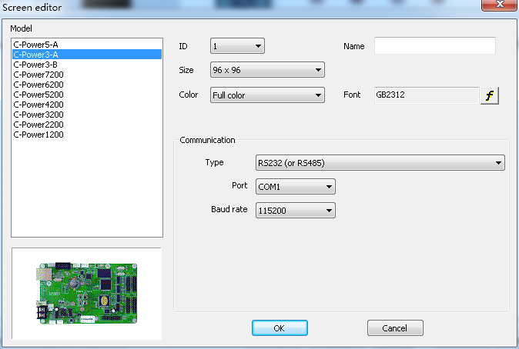
figure 7
- Network mode
There are the following setting items after connecting the network port with the control panel.
      - IP address: the IP address of the control panel
Local area network: if it is local area network or the control panel is connected by net twines, user can directly input IP address of the control panel (set IP address by using LedTool).
Internet: if the control panel is connected by internet, user should input IP address of the internet gateway.
      - ID code: the IP package ID code of the control panel (such as password).
ID code should be the same as the control panel setting, so that it can be recognized and controlled by the control panel.
      - Port: network port.the default port number is 5200.

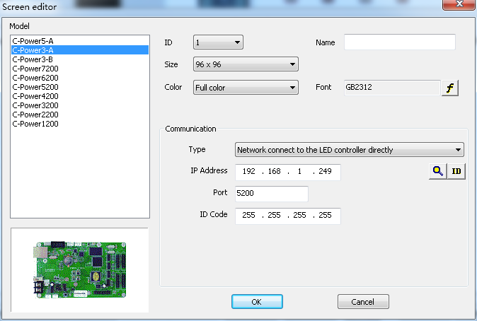
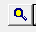
figure 8
If there has been controllers connected to the local area network,click to search the controllers ,Then click “refresh” button to refresh the information of controllers.select the controller you want to Connect to the computer ,and then click “OK” to confirm which you choose.As shown in figure 9,figure 10.
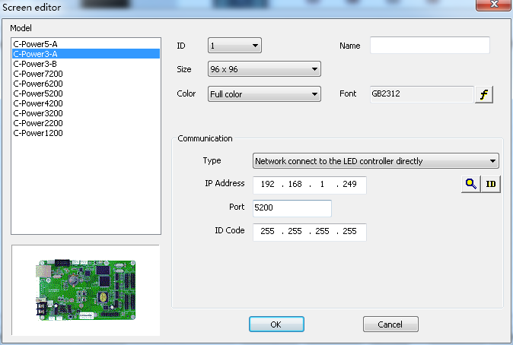

Click here to search the controllers which have connected to the network
figure 9
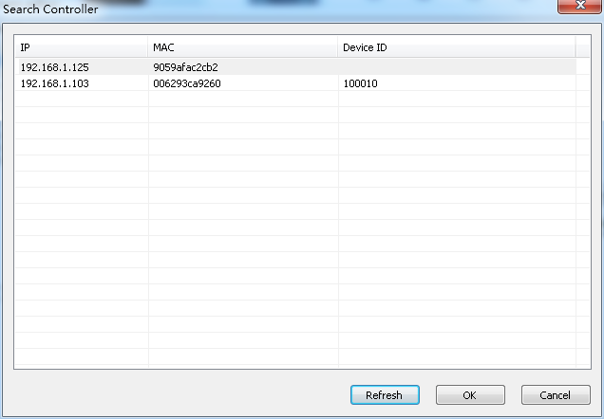

1.Click here to refresh the information of controllers
3.Click “OK” to confirm
2.Click and select the controller you want to connect to the computer
figure 10
Click or can switch the controllers’ information of device ID and IP address which have been connected to the computer.as shown in figure 11，figure12.
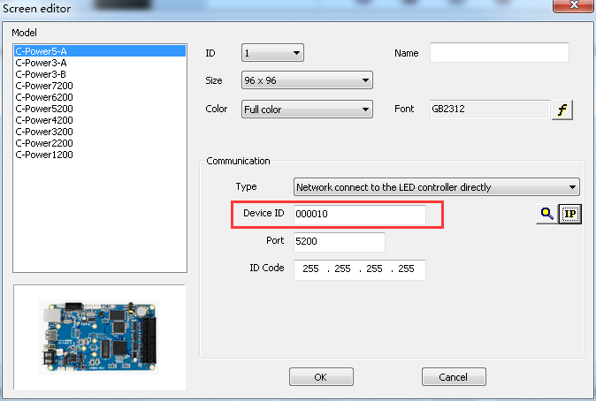
figure 11
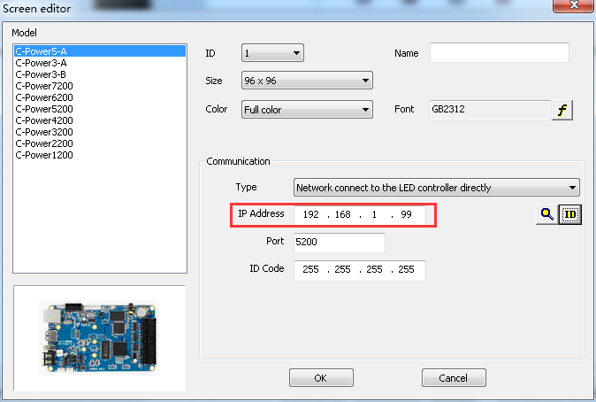
Figure 12
Once the “setup signs”has been done,LedCross will create a program automatically.now you can edit and manage the program.

B．C-Power parameters setting
Led Cross supports all the controllers made by lumenchina,we will take C-Power2&3 series as an example to show you how to set up the parameters.

1.Enter the Ledtool
Click“Tools”—“Ledtool”—“C-Power20/30” then into the interface of parameters setting，as shown below：
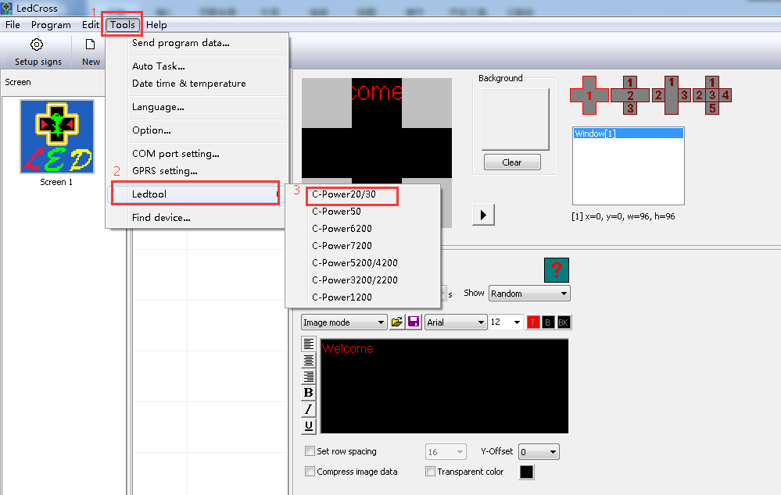
图 13

2. Cross wiring
There are many ways for Cross to wiring according to the module size，the ways to wiring can refer to the relevant guide.

C．edit and manage programs

1.learn about the interface of software
The interface is as follows when running the software.the interface consists of several parts.
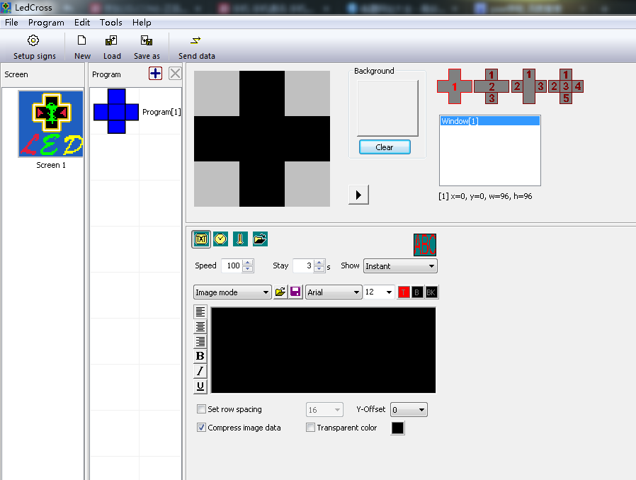
Preview program here
Select the type of content
4 layout windows for you to select
Add background
select and edit the zone corresponding to the serial number
Tool bar
Edit and manage the programs
Menu bar
Edit and adjust the content
图 14

You can send the contents by Led cross such as video,image,animation,doc/excel documents,text,clock temperature and humidity data .

2. Create and edit the programs
Led Cross has 4 layout windows to select,we will take layout 1 and layout 2 as examples to show you how to edit the contents.
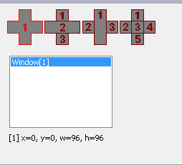
4 layout windows
2.1.Edit the contents of layout 1：
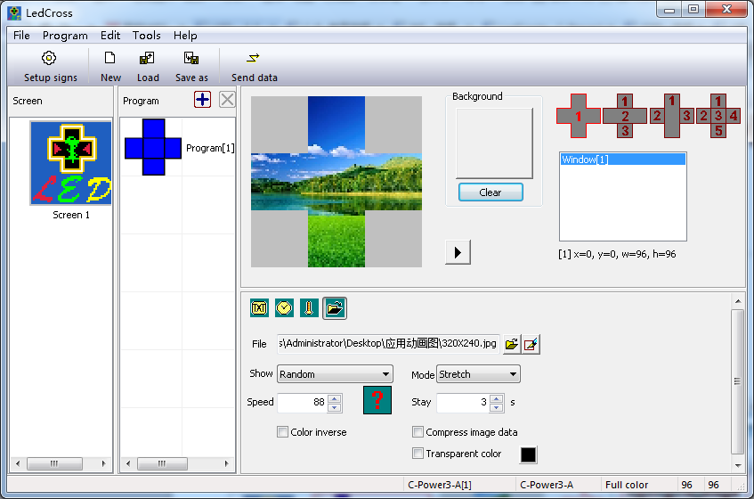
1.click and select the program
2.select the layout window，we select layout 1 as example
4.set the parameters to reach the effect
IT’s usually used for text overlay effct and text hollow out
6.click here to send the programs to the screen
3.select the type of content,we select image as example.
5Click here to preview the program
Click“send to current”in the pop-up window，then the programs will display in screen.
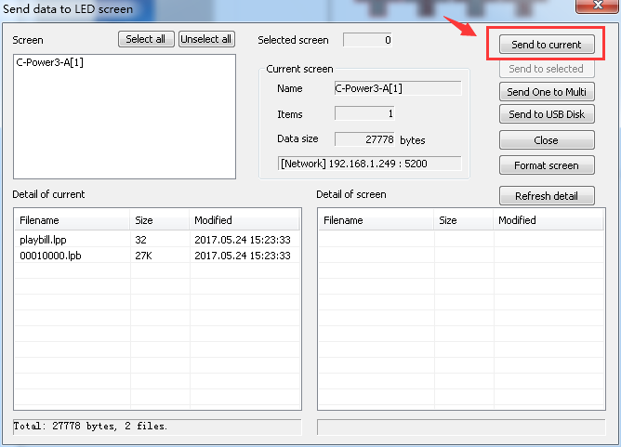
2.2 Edit the contents of layout 2：
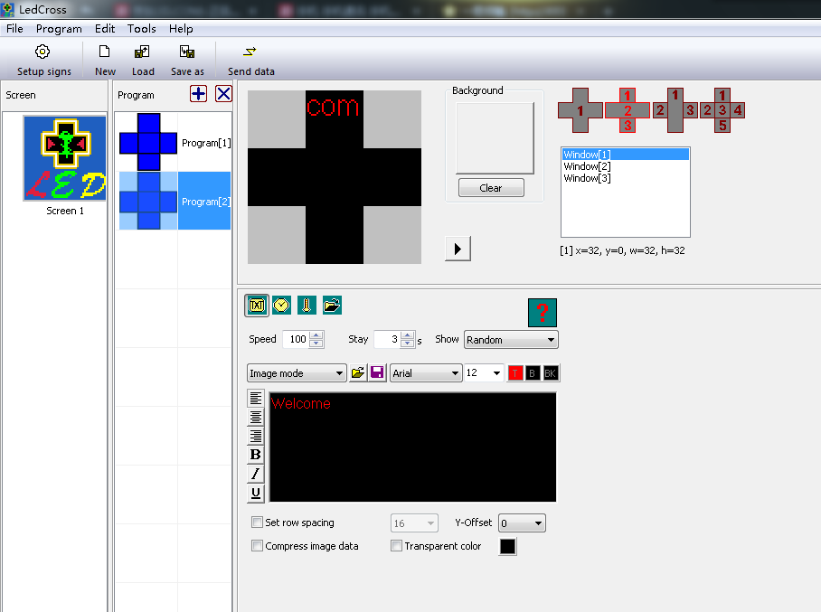
3.Click and select layout 2
1.Click here to add program

4.选择窗口序列号对各窗口内容进行编辑
2.Click program2

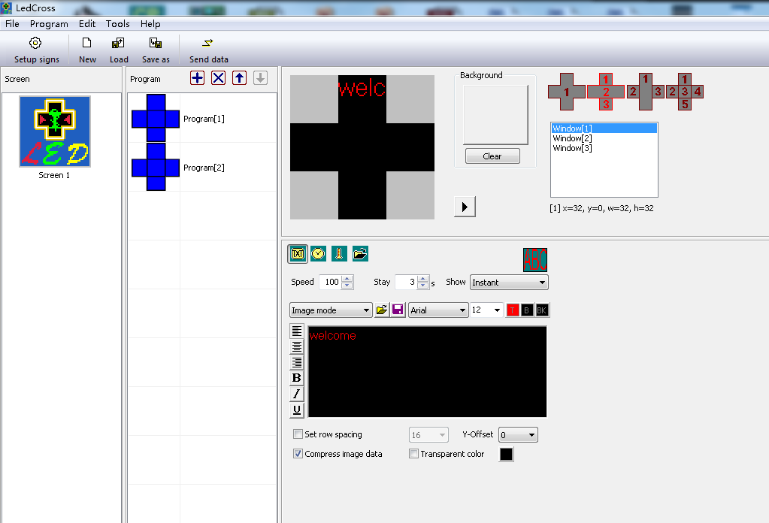
1.select windows[1]
2.click here to open file
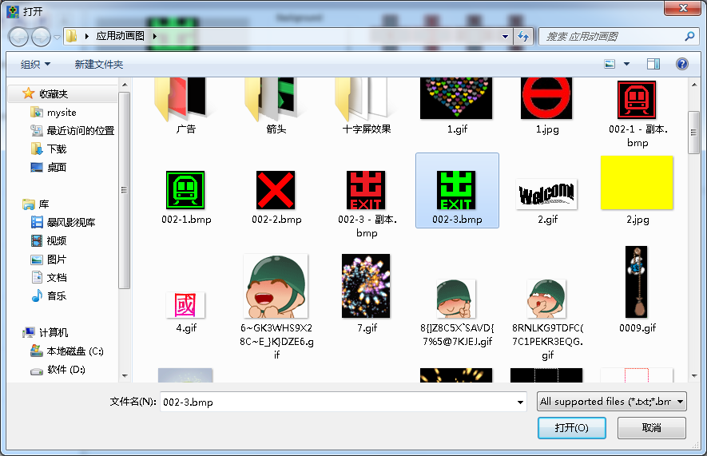
1.select the image you want to send
2.click“open”
2.3.Then edit Windows[2] and Windows[3] in the same way.
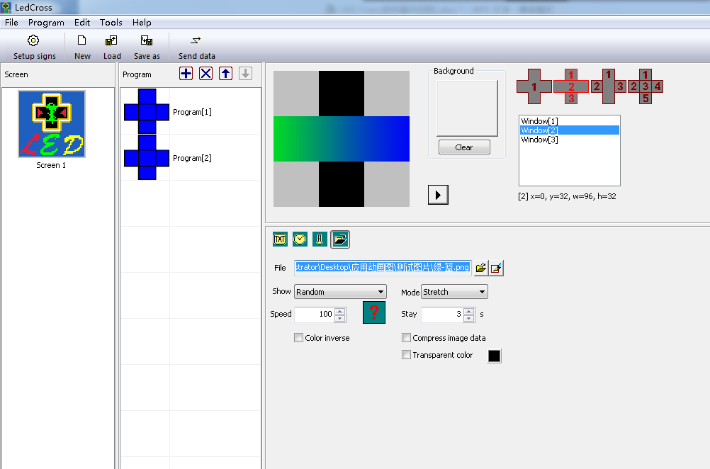
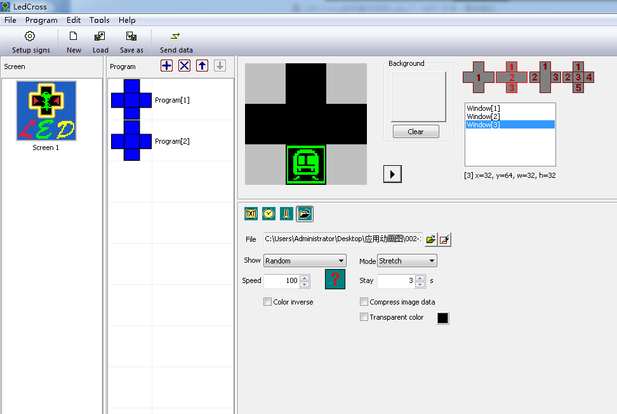
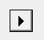
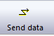
Click to preview the programs after you finish editing，adjust the parameters and then click to send programs data to screen.
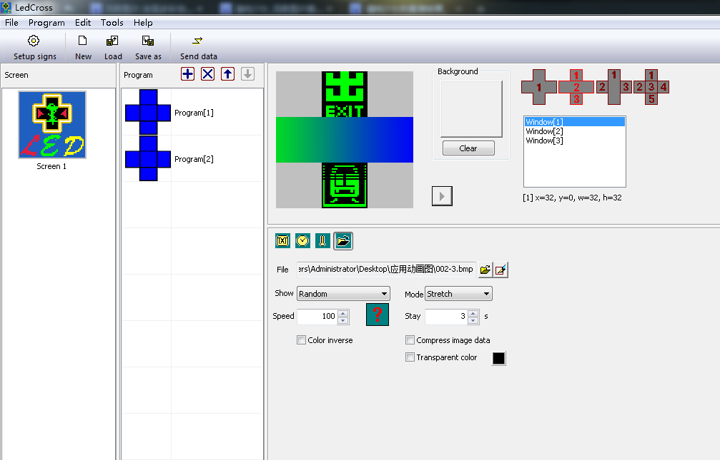
2.click here to send programs to screen
1.click here to preview the program

There is the same way to edit layout 3 and layout4.
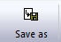
If you want to save the programs,click

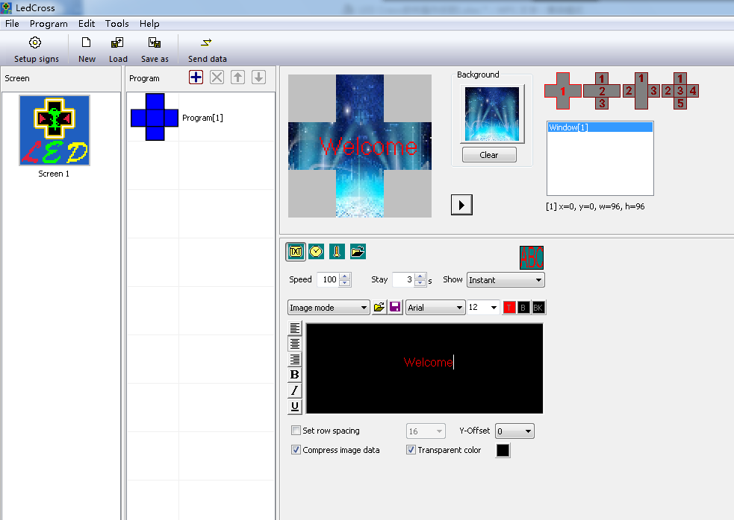
Click here to save programs
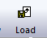
Click to load the programs with a .lpl filename.
Cick here to load the programs

Initial password is “16888”, please change the password timely and remember the new one.
For port number of PC COM port, it can also be modified through Menu Bar “Tools” – “COM port setting” after defining LED screen. User needn’t enter “Setup signs ” again.
The baud rate of the control card can be changed by LedTool, see engineer’s manual.
The network parameters of the control card “IP address, ID code, Port” can be changed by LedTool, see engineer’s manual.

